CV – Wg Cdr (Dr) Rajeev Chauhan

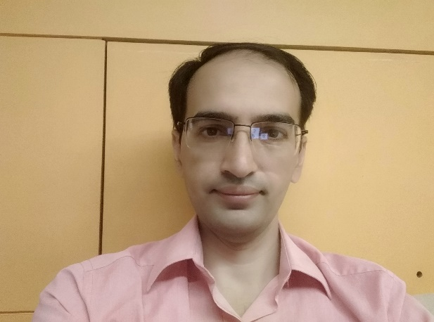

|  |  |  |  |
| --- | --- | --- | --- |
| **Present Position** | | Classified Specialist (Medicine) and Cardiologist, Command Hospital (Air Force), Bangalore | |
| **Past Appointment** | | Clinical Tutor, Dept of Medicine, AFMC  Physician at Air Force Hospital Amla | |
| **Education / Training** | | **College / University** | |
| **MBBS** | | AFMC Pune, MUHS Nashik | |
| **MD (Medicine)** | | AFMC Pune, MUHS Nashik | | |
| **DM (Cardiology)** | | PGIMER, Chandigarh | | |
| **Interventional Procedures Performed** | | More than 1000 interventional procedures of Angiography, Angioplasty, CHIP Procedure, Pacemakers,ICD etc. | | |
|  |  | | | |
| **PUBLICATIONS** | | | 15 National & International publications | |
|  | | |  | |

Publications

|  |  |
| --- | --- |
| 1 | Behera V, Behera MK, **Chauhan R**, Nair V. Duchenne muscular dystrophy. BMJ Case Rep. 2014 Jun 10;2014. pii: bcr2014205296. doi: 10.1136/bcr-2014-205296. PubMed PMID: 24916987. |
| 2 | Behera V, **Chauhan R**, Sinha S, Nair V. Anaphylactic Shock Secondary to Intravenous Iron Sucrose in Chronic Kidney Disease. Indian J Hematol Blood Transfus. 2015 Sep;31(3):391-3. doi: 10.1007/s12288-014-0475-0. Epub 2014 Nov 18.PubMed PMID: 26085728; PubMed Central PMCID: PMC4465511. |
| 3 | **Chauhan R**, Mendonca S. Adequacy of twice weekly hemodialysis in end stage renal disease patients at a tertiary care dialysis centre. Indian J Nephrol. 2015 Nov-Dec;25(6):329-33. doi: 10.4103/0971-4065.151762. PubMed PMID: 26664206; PubMed Central PMCID: PMC4663768. |
| 4 | Sashindran VK, **Chauhan R**. Antiretroviral therapy: Shifting sands. Med J Armed Forces India. 2016;72(1):54-60. doi:10.1016/j.mjafi.2015.12.002 |
| 5 | Krishna Santosh Vemuri, Pruthvi C. Revaiah, Dinakar Bootla, **Rajeev Chauhan**, Krishna Prasad Nevali, Aditya Jandial, Man Updesh Singh Sachdeva, Dushyant Singh, Manoj Kumar Rohit, .Early T Cell Precursor Leukemia Presenting With Superior Vena Cava Syndrome and Cardiac Tamponade.JACC: CARDIOONCOLOGY.VOL. 2, NO. 5, 2020 |
| 6 | Krishna Prasad, Himanshu Gupta, Bhupendra Kumar Sihag, Dinakar Bootla, Prashant Panda, Arun Sharma, **Rajeev Chauhan**, Atit Gawalkar, Neelam Dahiya, Submitral aneurysm of varied aetiologies: a case series, European Heart Journal - Case Reports, Volume 5, Issue 2, February 2021, ytab066, https://doi.org/10.1093/ehjcr/ytab066 |
| 7 | Yash Paul Sharma, Prashant Panda, **Rajeev Chauhan**\* , Krishna Prasad, Jyothi Vijay. Combining reverse nano-crush and stentboost technique to optimize outcome for bifurcation stenting.Interv. Cardiol. (2021) 13(2), 274-277.ISSN 1755-5302 |
| 8 | Swamy AJ, **Chauhan R\***, Keshavamurthy G. Primary percutaneous coronary intervention during the COVID-19 pandemic: Recalibrate, restart and relearn. Med J Armed Forces India. 2021 Jul;77(Suppl 2):S520-S521. doi: 10.1016/j.mjafi.2021.06.008. Epub 2021 Jul 26. PMID: 34334925; PMCID: PMC8313070. |
| 9 | Rupesh Kumar , Vikram Halder, Yamasandi Siddegowda Shrimanth, Atit A Gawalkar, **Rajeev Chauhan**, Krishna Prasad, Manoj Kumar Ukadbhai Rohit, Sujithareddy Karri, Sheenam Walia, Avneet Singh.Acquired cyanosis secondary to RVOT obstruction due to pacemaker lead prolapse and vegetation in a child with ASD. Journal of Cardiology Cases. 2021.Accepted 16 September 2021.https://doi.org/10.1016/j.jccase.2021.09.014 |
| 10 | Kaur Navjyot, **Chauhan Rajeev,** Swamy Ajay. (2021). Rotablation: A single centre experience. Indian Heart Journal. 73. S45-S46. 10.1016/j.ihj.2021.11.087. |
| 11 | **Chauhan Rajeev**, Swamy Ajay, Kaur Navjyot , Bhat Keshavamurthy. (2021). Clinical and angiographic outcomes for left main PCI. Indian Heart Journal. 73. S84-S85. 10.1016/j.ihj.2021.11.172. |
| 12 | Kumar R, Chadha D, Chaddha A, **Chauhan R**, Singh N, Kamal P, Mishra A, Kaur N. The Safety and Long-Term Efficacy of Carotid Artery Stenting: An All-Comers Registry. Cureus. 2022 Nov 30;14(11):e32060. doi: 10.7759/cureus.32060. PMID: 36600837; PMCID: PMC9800945. |
| 13 | **Chauhan R,** Otaal PS. Intra-Aortic Balloon Pump During Percutaneous Coronary Intervention in ST-Elevation Myocardial Infarction With High Thrombus Burden and Cardiogenic Shock. Cureus. 2023 Jan 25;15(1):e34188. doi: 10.7759/cureus.34188. |

**AFMRC Project-** Ongoing-01 (2022-24)

Comparison between Resting full cycle ratio (RFR) versus fractional flow reserve (FFR) on coronary lesions with intermediate significance