**Dr. Abhishek Kumar**

**Army Hospital Research and Referral, Delhi**

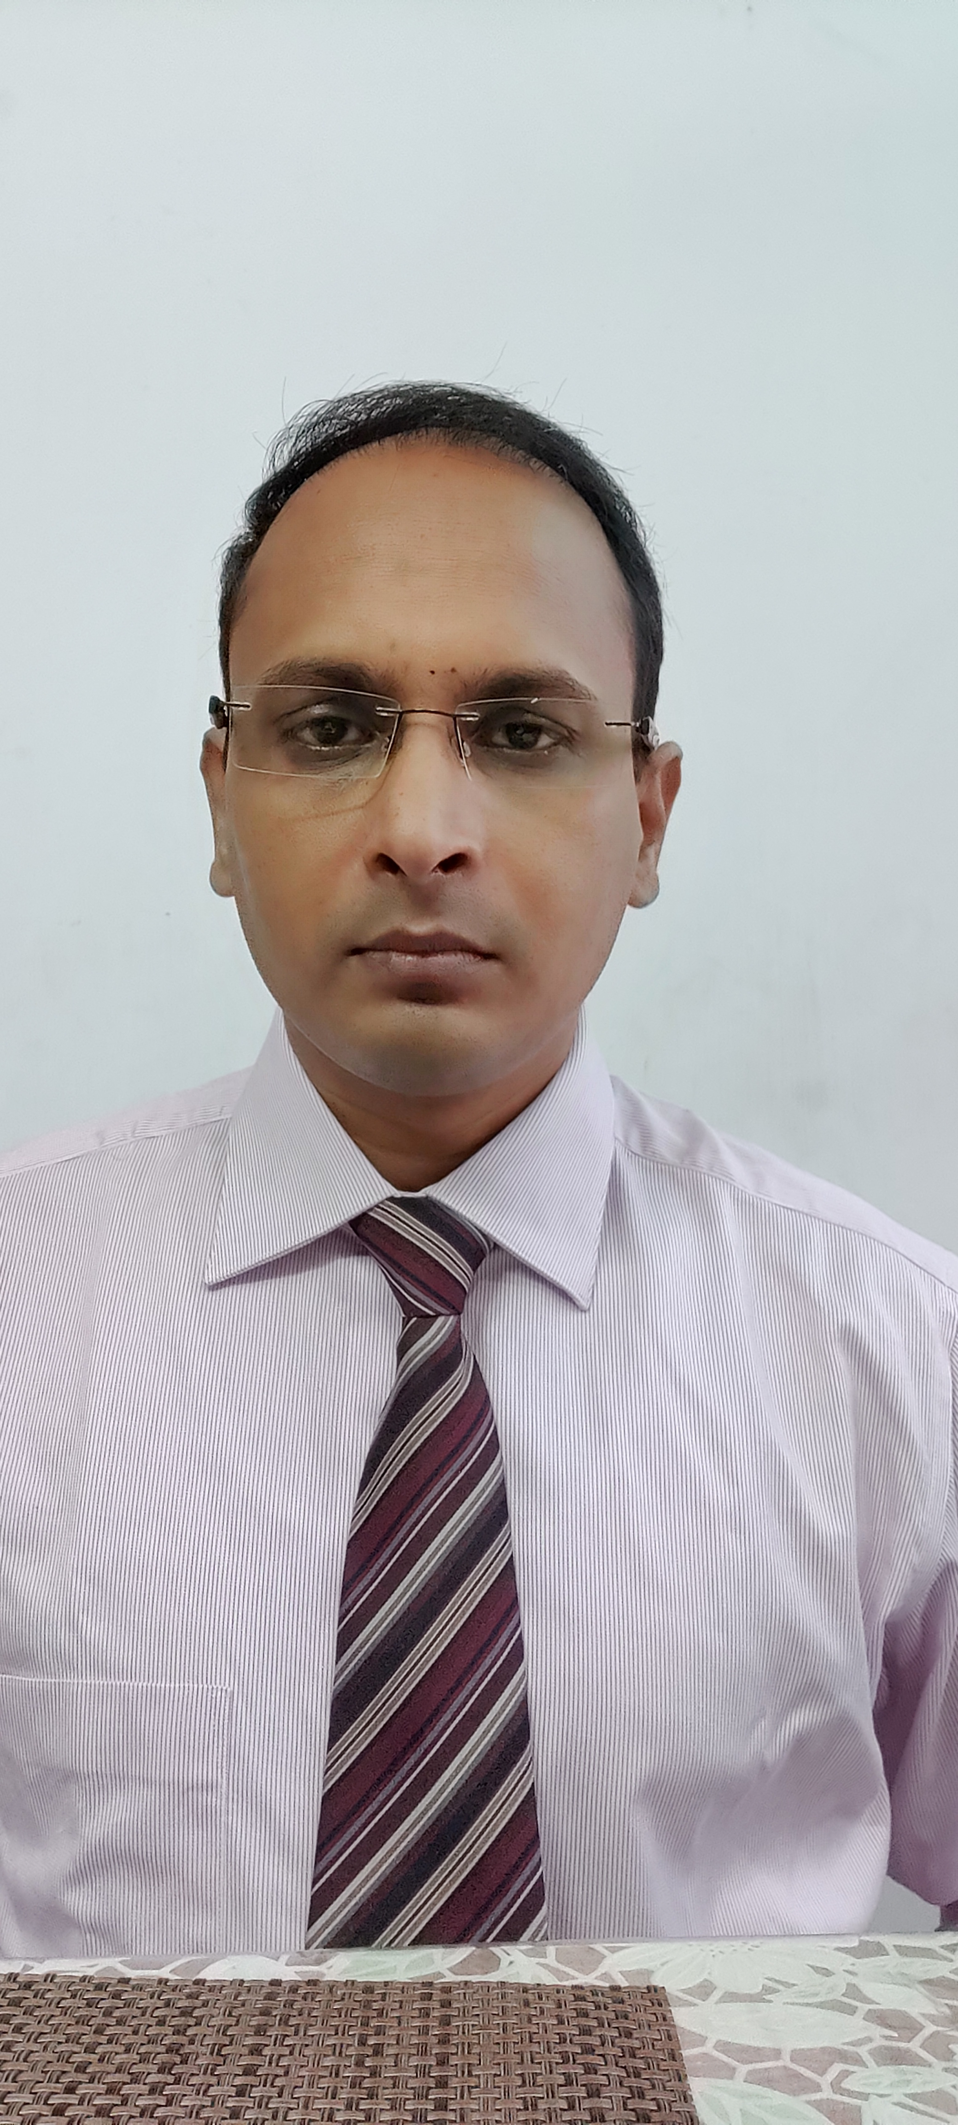

**MBBS**: AFMC, Pune

**MD (Medicine)**: Command Hospital, Bangalore

**DNB rheumatology**: Army Hospital (Research and Referral), Delhi

**Publications**: 12

*Diagnostic utility of RF and ACPA in Indian population.*

*Stem cell transplant in systemic sclerosis in India*

**Books chapters**: 3

**Present affiliation**: Army Hospital Research and Referral, Delhi