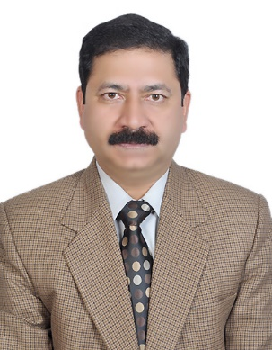BRIG PK SHARMA

Consultant (Med & GE)

CH(EC)

Alumnus of AFMC (MBBS, MD)

DM(GE)-AIIMS, New Delhi

Contributions to textbooks & Updates in Medicine & Gastroenterology

Reviewer for Journals in Medicine & Gastroenterology

Published 11 International and 16 National original research papers.

Awards & Felicitations:Young Investigator ISG(2006);COAS Commendation(2011);FICP(2014)