**CURRICULUM VITAE**

**PAVITRA MANU DOGRA, MD, DM, FISN, FASN, FRCP Edin**

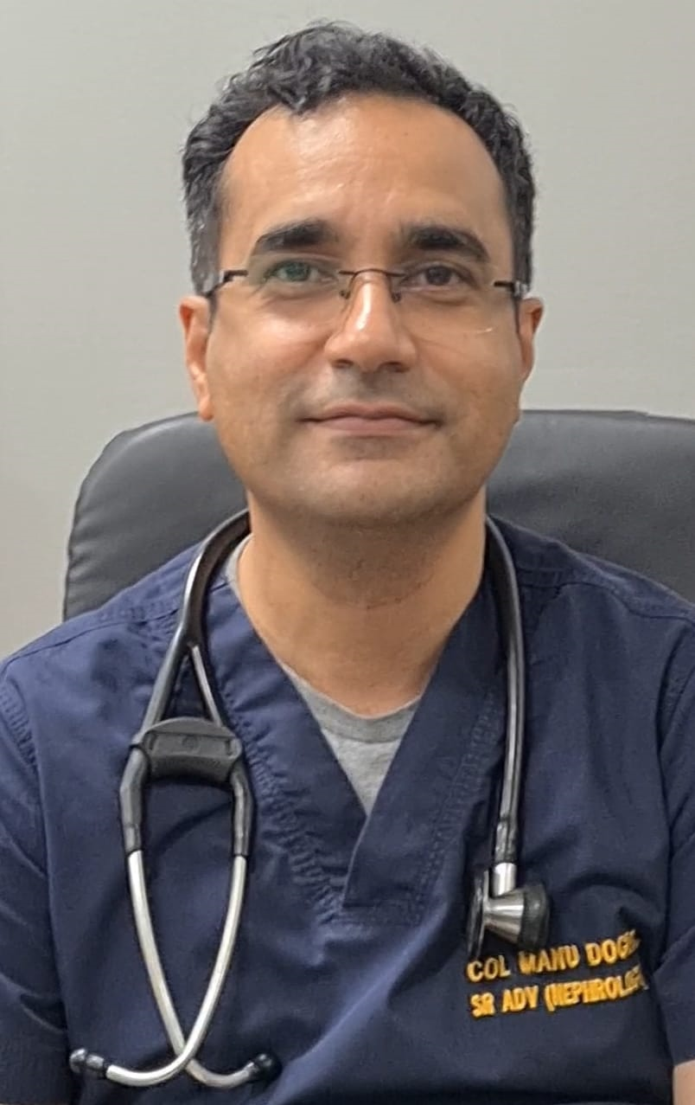

**APPOINTMENT** : Col Pavitra Manu Dogra

Senior Advisor (Medicine & Nephrology)

Dept of Nephrology

Army Hospital (R&R), Delhi Cantt-110010

**DATE OF BIRTH** : 24 April 1974

**TELEPHONE NO.** : 9051144883

**EMAIL** : dodgemanu@gmail.com

**MEDICAL ACADEMIC QUALIFICATIONS**

1. **MBBS** : Armed Forces Medical College/Pune University (1996)
2. **MD (Medicine)**: Armed Forces Medical College/Pune University (2004)
3. **DM (Nephrology)**: All India Institute of Medical Sciences (2011)

**FELLOWSHIPS** : 1. **FASN**: Fellowship of American Society of Nephrology

2. **FISN**: Fellowship of Indian Society of Nephrology

3. **FRCP (Edin)**: Fellowship of Royal College of Physicians (Edinburgh)

**HONOURS AND AWARDS**

1. Chief of Army Staff Commendation (2001)
2. United Nations Commendation (2006)

**EXTRAMURAL DUTIES IN NEPHROLOGY**

1. Formerly Director, Armed Forces Organ Retrieval and Transplantation Authority (AORTA)
2. Nephrology Expert for AIIMS Nagpur Staff Selection committee (2020-22)
3. External Examinership for Nephrology (Final) examinations for DM and DrNB

**OFFICE BEARER IN NATIONAL SOCIETIES**

1. Treasurer, Indian Society of Nephrology- Northern Zone (Oct 2018 onwards).

**NEPHROLOGY SOCIETY MEMBERSHIP**

1. **National societies:** 
   1. Indian Society of Nephrology
   2. Peritoneal Dialysis Society of India
   3. Indian Society of Organ Transplantation
   4. Armed Forces Medical Research Committee
   5. Delhi Nephrology Society
   6. Indian Society of Nephrology-Northern zone
   7. Indian Academy of Nephrology
2. **International societies:**
   1. American Society of Nephrology
   2. European Renal Association- European Dialysis and Transplant Association
   3. International Society of Nephrology
   4. Royal College Of Physicians Edinburgh

**AREAS OF INTEREST**

1. Peritoneal dialysis – Insertion techniques and survival outcomes
2. Interventional Nephrology
3. Renal Transplantation

**PUBLICATIONS: 32 (International and National)**

**RECENT PUBLICATIONS (Jan – Jun 2023)**

1. Sood V, Mishra K, Bahl R, Singhal G, **Dogra PM**, Suman P, Singh V. Hyperviscosity syndrome complicating immunoglobulin G myeloma-Cognisance of early plasmapheresis is crucial. Semin Dial. 2023 Mar; 36(2):175-177. doi: 10.1111/sdi.13135. Epub 2022 Dec 21. PMID: 36541085.
2. Singh B, **Dogra PM**, Sood V, Singh V, Katyal A, Dhawan M, *et al*. Spectrum, Outcomes, and Mortality Predictors of Acute Kidney Injury among Non-COVID-19 Patients during COVID-19 Pandemic: Data from Four Intensive Care Units. Indian J Crit Care Med 2023;27(2):119–126.
3. Singh V, **Dogra PM**, Singh P, Ghosh I, Singhal G. Renal limited sarcoidosis presenting with acute kidney injury. Medical Journal Armed Forces India, 2023 (in press).