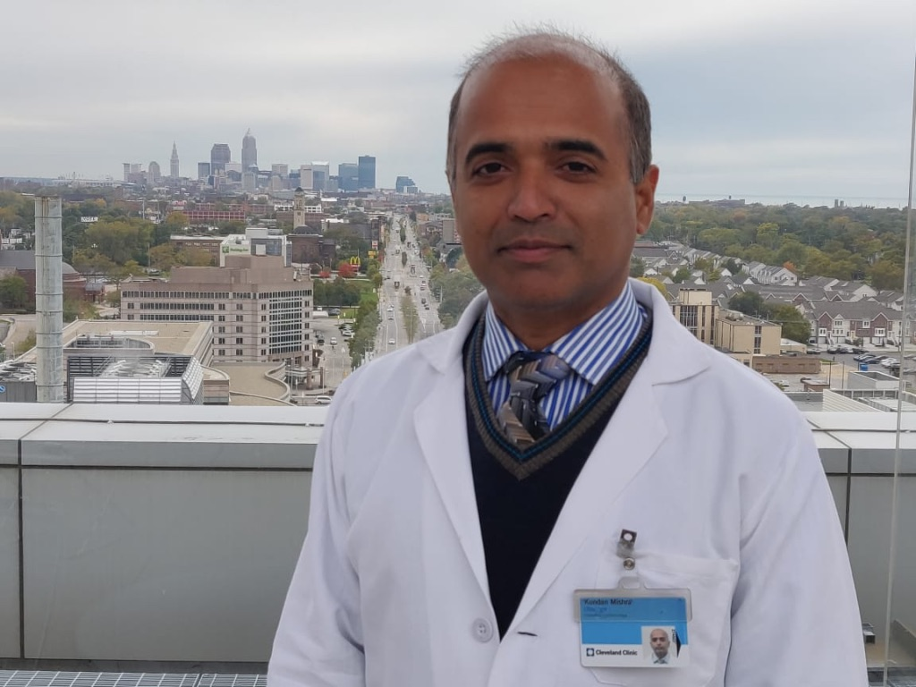

**Col (Dr) Kundan Mishra, MD, DNB, PGDHHM, PGDCR, MNAMS, DM**

Professor (Medicine) and HoD Clinical Haematology & BMT

Command Hospital (CC), Lucknow, India (PIN: 226002)

Mob: +91 987123179 Email ID: [mishrak20@gmail.com](mailto:mishrak20@gmail.com)

**Col (Dr) Kundan Mishra, MD, DNB, PGDHHM, PGDCR, MNAMS, DM**

Professor (Medicine) and HoD Clinical Haematology & BMT

Command Hospital (CC), Lucknow, India (PIN: 226002)

Mob: +91 987123179 Email ID: [mishrak20@gmail.com](mailto:mishrak20@gmail.com)

**Honors and Awards:**

2013: ‘**Chief of Army Staff Commendation**’ for meritorious service on high altitude illnesses (High Altitude Medical Research Centre and153 General Hospital, Leh, India).

2017: **ASH abstract achievement award** for abstract titled, ‘Bleeding Risk Assessment by Sonoclot in Severe Immune Thrombocytopenia’ at 59th ASH annual meeting, Atlanta, USA.

2018: Second in national quiz at Young Hematologist Orientation Programme, SGPGI Lucknow, India.

2023: Best oral presentation for paper titled, Bleeding risk assessment by Sonoclot in immune thrombocytopenia at 5th Haematology Update, AIIMS Jodhpur, India

2023: ‘**General Officer Commanding in-Chief (WC) Commendation**’ for meritorious service on haematological disorders and BMT (Army Hospital R&R, New Delhi, India).

**Scientific Committee Contributions:**

**Associate Editor**:

Medical Journal Armed Forces (MJAFI), Pune

**Reviewer**:

IJHBT and multiple national & international journals

**Invited presentation:**

2014: Annual Medical Sciences Update, Thimphu, Bhutan: presented oral paper titled, ‘Microvascular and macrovascular complication in patients of Diabetes Mellitus Type 2 in Bhutan’.

2017: JSH Annual Meeting, Tokyo, Japan: presented poster titled, ‘Outcome of ocular changes after treatment of aplastic anemia.’

2017: ASH 59th Annual Meeting, Atlanta, USA: presented poster titled, ‘Bleeding Risk Assessment by Sonoclot in Severe Immune Thrombocytopenia.’

2018: Indian Myeloma Conference, New Delhi, India: presented oral paper titled, ‘Real-world Experience of Generic Carfilzomib for Relapsed Refractory Multiple Myeloma (RRMM).’

2018: ICBMT, Busan, South Korea: presented an oral paper titled, ‘Estimated Energy Requirement in Patients Undergoing Hematopoietic Stem Cell Transplantation – A Prospective Study from Tertiary Care Centre in North India.’

2020: RGCON, Delhi: delivered a talk on, ‘Management of Aplastic Anemia’.

2020: IMAGE Meet, Hyderabad: delivered a talk on, ‘Management and Outcomes of FLT3 Positive Patients in AML’.

2021: Innovation in Oncology Meet, Faridabad: delivered a talk on, ‘Changing landscape in multiple myeloma with advent of Mabs’.

2022: Precision Oncology Meet, Jaipur: delivered a talk on, ‘Role Of Novel Therapies In ALL’.

2022: Hematocon, Kolkata: delivered a talk on, ‘Transplant in Non-malignant Disorder’.

2023: Hematology Express 2023, Jaipur: delivered a talk on, ‘First hit, the best hit - Managing Transplant Ineligible Newly Diagnosed Multiple Myeloma with mABs’.

**Peer-reviewed manuscripts:**

1. Sahu KK, Mishra K, Dhibar DP et.al. Priapism as the Presenting Manifestation of Multiple Myeloma. Indian J Hematol Blood Transfus. 2017 Mar;33(1):133-136.
2. Jandial A, Mishra K, Khadwal A et al. Headache in a case of β thalassaemia. BMJ 2017;358:j3482.
3. Mishra K, Jandial A, Bal A, et al. Verrucous Skin Lesions in a Case of Acute Lymphoblastic Leukemia: A Rare Manifestation of Cytomegalovirus Infection. Indian J Hematol Blood Transfus. 2018 Apr;34(2):378-380.
4. Kaundal R, Bhatia P, Jain A, Jain A, Nampoothiri RV, Mishra K, Jandial A, Goni D, Sandal R, Jindal N, Meshram A, Sharma R, Khaire N, Singh C, Khadwal A, Prakash G, Das R, Varma N, Varma S, Malhotra P, Lad DP. Randomized controlled trial of twice-daily versus alternate-day oral iron therapy in the treatment of iron-deficiency anemia. Ann Hematol. 2020 Jan;99(1):57-63. doi: 10.1007/s00277-019-03871-z.
5. Khera S, Pramanik SK, Yanamandra U, Mishra K, Kapoor R, Das S. Dapsone: An Old but Effective Therapy in Pediatric Refractory Immune Thrombocytopenia. Indian J Hematol Blood Transfus. 2020 Oct;36(4):690-694. doi: 10.1007/s12288-020-01286-9.
6. Mishra K, Kumar S, Jandial A, Sahu KK, Sandal R, Ahuja A, et al. Real-world Experience of Rituximab in Immune Thrombocytopenia. Indian J Hematol Blood Transfus. 2021 Jul;37(3):404-413. doi: 10.1007/s12288-020-01351-3. PMID: 34267459.
7. Mishra K, Pramanik S, Jandial A, Sahu KK, Sandal R, Ahuja A, et al. Real-world experience of eltrombopag in immune thrombocytopenia. Am J Blood Res. 2020 Oct 15;10(5):240-251.
8. Yanamandra U, Boddu R, Pramanik S, et al. Prevalence and Clinical Characteristics of Post-Thrombotic Syndrome in High-Altitude-Induced Deep Vein Thrombosis: Experience of a Single Tertiary Care Center from Real-World Settings. High Alt Med Biol. 2020 Dec;21(4):319-326. doi: 10.1089/ham.2020.0053. Epub 2020 Jul 20. PMID: 32707006.
9. Sandal R, Mishra K, Jandial A, Sahu KK, Siddiqui AD. Update on diagnosis and treatment of immune thrombocytopenia. Expert Rev Clin Pharmacol. 2021 May;14(5):553-568. doi: 10.1080/17512433.2021.1903315. PMID: 33724124.
10. Jandial A, Mishra K, Sandal R, Kant Sahu K. Management of BK virus-associated haemorrhagic cystitis in allogeneic stem cell transplant recipients. Ther Adv Infect Dis. 2021 Feb 3;8:2049936121991377. doi: 10.1177/2049936121991377. PMID: 33614030; PMCID: PMC7871057.
11. Yanamandra U, Sharma R, Shankar S, Yadav S, Kapoor R, Pramanik S, Ahuja A, et. al. Survival Outcomes of Newly Diagnosed Multiple Myeloma at a Tertiary Care Center in North India (IMAGe: 001A Study). JCO Glob Oncol. 2021 May;7:704-715.
12. Mishra K, Pramanik S, Sandal R, Jandial A, Sahu KK, Singh K, et. al. Safety and efficacy of azathioprine in immune thrombocytopenia. Am J Blood Res. 2021 Jun 15;11(3):217-226.
13. Mishra K, Kumar S, Sandal R, Jandial A, Sahu KK, Singh K, et al. Safety and efficacy of splenectomy in immune thrombocytopenia. Am J Blood Res. 2021 Aug 15;11(4):361-372.
14. Sahu KK, Mishra K, Jandial A, Sandal R. COVID-19 vaccination of patients with cancer: Do's and Don'ts. Med J Armed Forces India. 2021 Jul;77(Suppl 2):S508-S510.
15. Prakash G, Jain A, Sahu K, Bal A, Singh C, Basher R, et al. Bendamustine in combination with ifosfamide, etoposide, and vinorelbine (VIBE) is an effective salvage regimen for heavily pre-treated patients with relapsed or refractory Hodgkin lymphoma: a single-center experience. Blood Res. 2021 Aug 12. doi: 10.5045/br.2021.2021039.
16. Mishra K, Kumar S, Ninawe S, Bahl R, Meshram A, Singh K, et al. The clinical profile, management, and outcome of febrile neutropenia in acute myeloid leukemia from resource constraint settings. Ther Adv Infect Dis. 2021 Aug 4;8:20499361211036592.
17. Mishra K, Barki S, Pattanayak S, Shyam M, Sreen A, Kumar S, Kotwal J. COVID-19 Vaccine-Induced Thrombosis and Thrombocytopenia: First Confirmed Case from India. Indian J Hematol Blood Transfus. 2022 Jan;38(1):196-198.
18. Mishra K, Kumar S, Singh K, Jandial A, Sandal R, Sahu KK, et al. Real-world experience of anti-D immunoglobulin in immune thrombocytopenia. Ann Hematol. 2022 Apr 8. doi: 10.1007/s00277-022-04829-4. Epub ahead of print. PMID: 35396605.
19. Singh K, V P, Ahuja A, Somasundarum V, Mishra K, Chatterjee T. Correlation of Thrombosis and Clinicohematological Parameters with JAK2V617F Mutation in Philadelphia-Negative CMPNs: A Study from India. J Lab Physicians. 2022 Oct 20;14(4):394-397.