**Gp Capt Rakhi Malhotra**

**Senior Advisor Medicine & Endocrinologist, CHAFB**

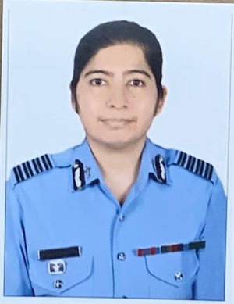

**Academic credentials-**

**MBBS – AFMC Pune**

**MD Medicine- Delhi University**

**DM Endocrinology AIIMS, New Delhi**

**Publications and awards-**

**18 publications (National – 06, International -12)**

**Academic awards:**

**Chief of Naval Staff Bronze medal in Pathology**

**AV Gandhi award and Gold medal by the Endocrine society of India for best research work in Endocrinology- 2019**

**Commendations : AOC IN C commendation in 2012**

**Areas of research interest**

**Pediatric Endocrinology, Metabolic bone disease**