Dr (Lt Gen) CS Narayanan, VSM***
Head, Neurology
Manipal Hospitals, New Delhi

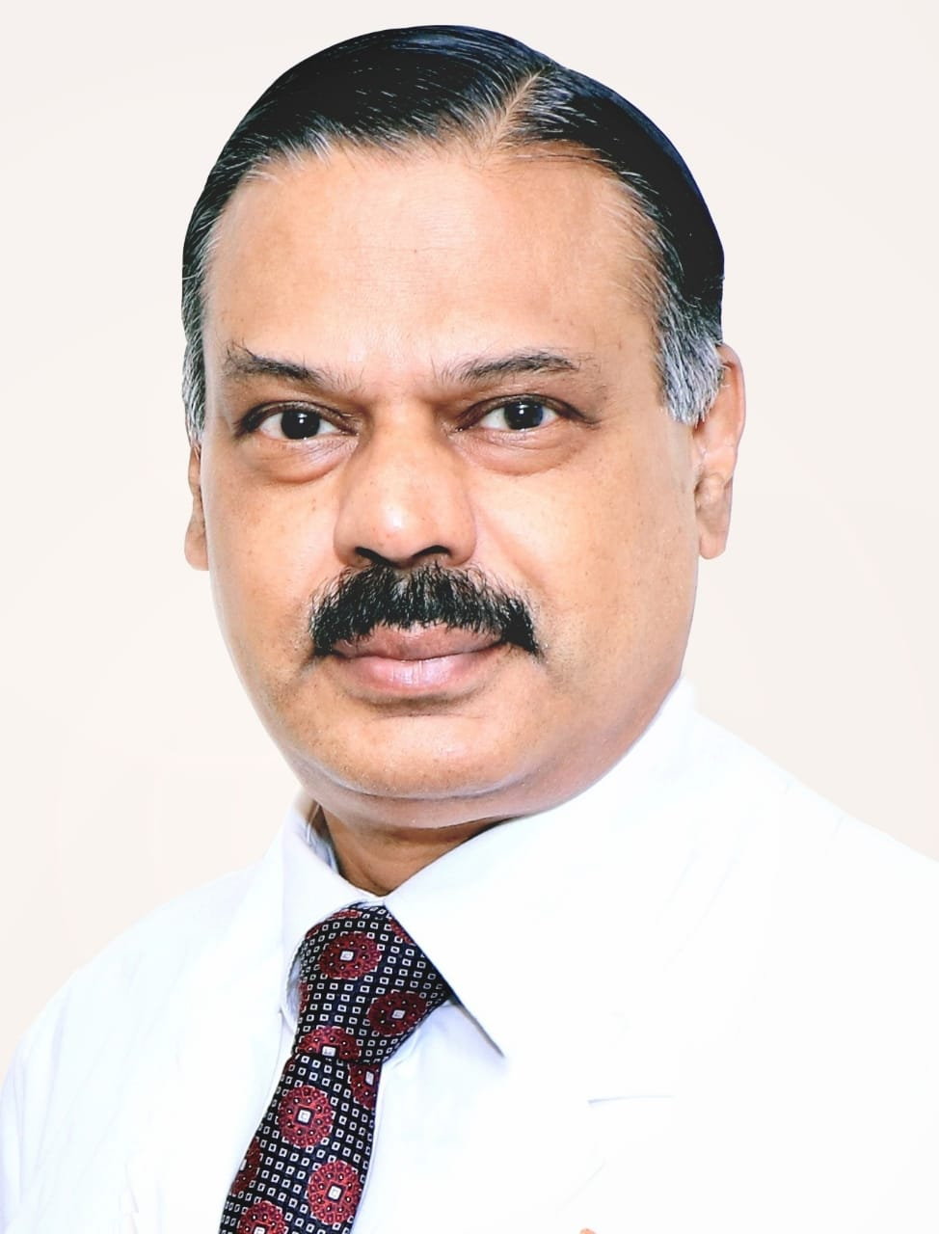

MBBS and MD from AFMC , DM (Neurology) from AIIMS
39 years service in the Armed Forces
Formerly
HOD (Neurology) Army Hospital (R&R)
Dean and Dy Commandant Army Hospital (R&R)
Special interest in Movement Disorders, Demyelinating disorders, Epilepsy and stroke
Unique distinction of being awarded the Vishisht Sewa Medal by the President of India 3 times
Awarded the Capital Foundation National Award by the Shri Naveen Patnaik, Hon’ble Chief Minister of Odisha

